Welcome back to school!
This year, we are fortunate enough to provide access to DreamBox for all our elementary students. Dreambox provides Intelligent Adaptive Learning that supports our math program. Click on the links to learn more:

-DreamBox overview for parents: https://www.youtube.com/watch?v=w_ciFHZA2E8

To access DreamBox at home (setup):
1. Go to your child’s District portal. https://portal.srvusd.net
2. Have your child login to his or her profile just as it would be done at school.
3. Click Setup Parent Access at the bottom of the page.

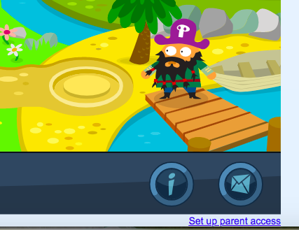

4. Follow the instructions to create a login (email) and password.
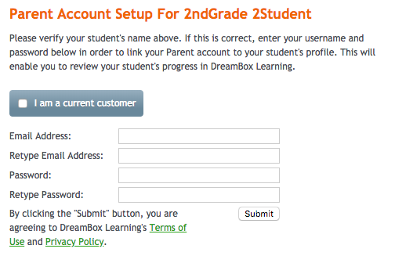

5. Read the Terms of Use and Privacy Policy.
6. Click Submit.

To log into your Family Insights Dashboard (after it is set up):
1. Go to http://play.dreambox.com.
2. Enter your email and password.
3. To see student progress, click the Family Dashboard button. Questions? We’ve got answers. Contact us at support@dreambox.com or call 877-451-7845. © 2015 DreamBox Learning, Inc. For problems logging into your District's portal, please contact your District for assistance.

Students can log in and access DreamBox at home, anytime:
- Log in to the student portal: https://portal.srvusd.net/LoginPolicy.jsp
- User name: Initials of their school site, dot, FirstInitialLastname (no spaces) ie: QR.flast
- Password: Capital “ID,# symbol, 6 digit student ID number (no spaces) ie: ID#123456
- If logging in on an ios device, log in through CLEVER app 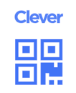
(available in the App store). https://clever.com/

To Use Dreambox Learning Math on your personal Ipad, install both of the following free apps :

Clever
Dreambox Learning Math

(both apps need to be on the iPad but you will only be using Clever for students that are using a Badge to login)

Open Clever app, allow camera (forward facing camera, it makes a difference), scan Badge in front of camera for student login OR

Use the single sign on option where students use their SRVUSD issued log on credentials.

Teachers can print out Badges and give students a copy to use at home. Please contact teacher for Badges

